OpenMP: Monte Carlo Simulation

Rui Gao

gaorui@oregonstate.edu

Project 1

CS 575

The probability is around 0.3%. That’s too amateur… I don’t know, maybe I am wrong.

|  |  |  |  |  |  |  |  |  |
| --- | --- | --- | --- | --- | --- | --- | --- | --- |
| Threads | Trials | | | | | | | |
|  | 10 | | 100 | | 1,000 | | 10,000 | |
|  | Pb. |  | Pb. |  | Pb. |  | Pb. |  |
| 1 | 0 |  | 0 |  | 0.1 |  | 0.25 |  |
| 2 | 0.1 |  | 0 |  | 0.1 |  | 0.25 |  |
| 4 | 0.1 |  | 0 |  | 0.1 |  | 0.25 |  |
|  | | | | | | | | |
|  | 100,000 | | | | 500,000 | | 1,000,000 | |
|  | Pb. | |  | | Pb. |  | Pb. |  | |
| 1 | 0.29 | |  | | 0.31 |  | 0.3 |  | |
| 2 | 0.29 | |  | | 0.31 |  | 0.3 |  | |
| 4 | 0.29 | |  | | 0.31 |  | 0.3 |  | |

Pb. = the probability of hitting the castle (%), Peak Performance (MegaMults/Sec).

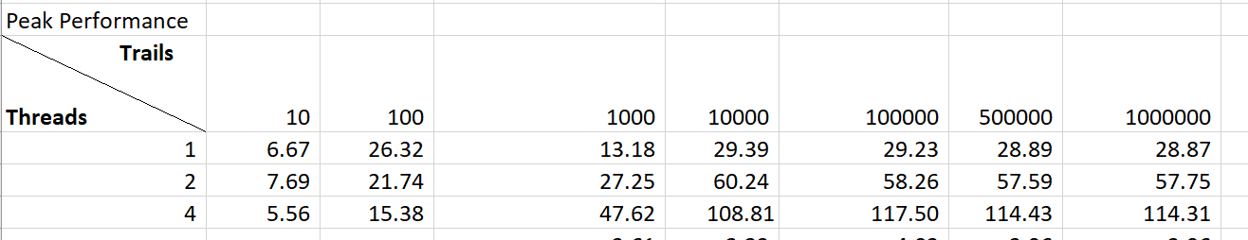

**Graph of performance vs. number of trials**

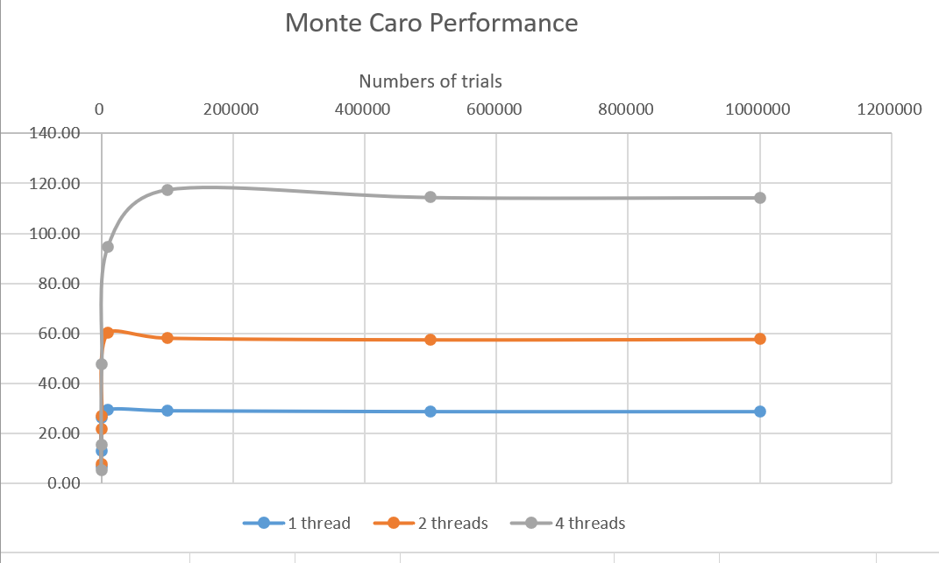

After 100,000 tries, the performance doesn’t increase with the trials.

**Graph of performance vs. number of threads**

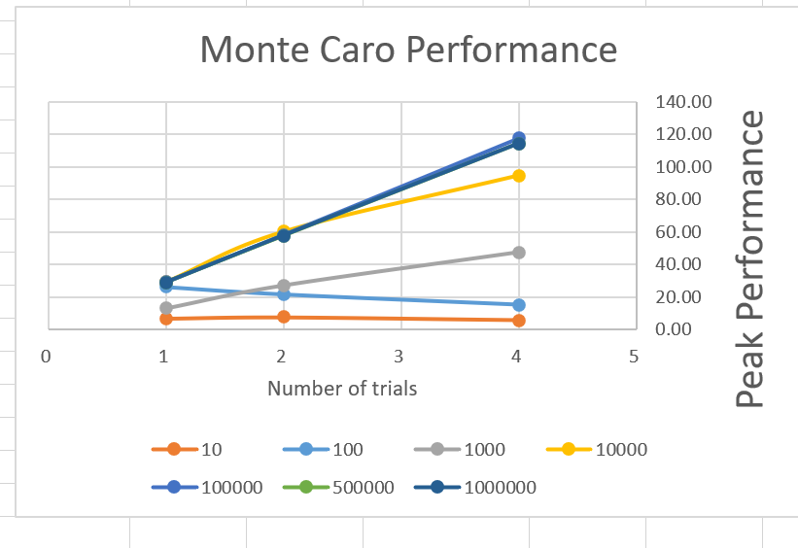

I also tried 8 threads for one time, they are almost 1.4 times.



16 threads, they are almost 1.7 times.



But when it’s 32 threads,



So, it will keep increasing until we use 32 threads, which is more than 16 that is the physical/real threads the 4900hs has.

**Fp, the Parallel Fraction.**

S = (Performance with four threads) / (Performance with one thread)

Fp = (4./3.)*( 1. - (1./S) )

Fp_1,000 = (4 / 3) * (1 – 1/3.61) = 0.964

Fp_10,000 = (4 / 3) * (1 – 1/3.22) =0.919

Fp_100,000 = (4 / 3) * (1 – 1/4.01) = 1.000

Fp_500,000 = (4 / 3) * (1 – 1/3.96) = 0.997

Fp_1,000,000 = (4 / 3) * (1 – 1/3.96) = 0.997

As the result, the Fp = Avg (Fp above) = 0.975